Week 7
Final Project Part 1: Optimization Technique and Implementation Project Report
Kashif Ali Syed
University of Cumberlands
MSCS-532-B01 – Algorithms and Data Structures
Brandon Bass

Introduction
High-Performance Computing (HPC) is used to solve large and complex scientific workloads that often run on supercomputers or distributed clusters. Performance is critical in HPC applications because even small inefficiencies can multiply into significant computational delays. The empirical study An Empirical Study of High Performance Computing (HPC) Performance Bugs investigates real-world HPC bugs and identifies patterns that affect system performance (Azad et al., 2023). One major finding is that memory access inefficiencies frequently cause performance degradation.
In this report, I focus on memory access optimization, a technique that improves how data is stored and accessed in memory. Because HPC applications often use large arrays and scientific datasets, memory access affects the performance of data structures directly. For additional clarity, this report considers memory access optimization as a type of data structure optimization, since changing how arrays are laid out or accessed improves the
performance of operations on these structures.
Overview of the Empirical Study on HPC Performance Bugs
The study by Azad et al. (2023) analyzed 1,729 performance-related commits across 23 HPC projects. They identified common root causes such as inefficient algorithms, missing parallelization, and inefficient micro-architecture usage. A key contribution of the study is a taxonomy of HPC performance bugs. One of the major categories is Inefficient code for the target micro-architecture, which includes issues related to memory locality and cache performance. Improper memory access patterns, such as random or indirect accesses, can lead to excessive cache misses. This matches previous research, which shows that memory locality strongly impacts overall execution speed (Jin et al., 2012). Thus, memory access issues are directly tied to performance bugs, and improving data locality can dramatically increase HPC performance.
Memory Access Optimization in HPC
Memory access optimization focuses on improving the efficiency of how programs fetch and store data in memory. CPUs rely heavily on cache memory, which is much faster than main memory. When data is accessed sequentially, cache lines are utilized more efficiently, reducing memory latency.
Two core principles of memory locality:
- Spatial locality, accessing data stored near recently accessed data
- Temporal locality, reusing recently accessed data soon again
These principles matter greatly in data structures: arrays and matrices benefit heavily from contiguous layouts, whereas irregular structures like linked lists often perform poorly in HPC.
The empirical study shows that many performance bugs relate to poor use of caches or inefficient memory behavior (Azad et al., 2023). NumPy arrays in Python offer a practical way to demonstrate optimized memory access because they are stored in contiguous memory and allow vectorized operations.

Strengths and Weaknesses of Memory Access Optimization
Strengths
Memory access optimization offers several important strengths in the context of high-performance computing and data structure optimization. One major advantage is that it can provide very large performance improvements without requiring changes to the underlying algorithm. Instead of redesigning the logic of the program, developers can simply reorganize how data is stored or accessed to achieve faster execution. This makes memory access optimization a powerful technique because performance gains come from improving efficiency rather than rewriting complex algorithms. Another strength is that memory access optimization works extremely well for array-based computations, which are common in scientific and engineering workloads. Arrays and matrices benefit from being stored in contiguous blocks of memory, allowing the CPU to load multiple values at once using cache lines. When data is accessed sequentially, the processor can reuse data in cache more effectively, significantly improving performance. Because HPC applications often involve large-scale vector and matrix operations, improving locality in these structures leads to measurable speed-ups.
Memory access optimization also aligns naturally with the types of workloads typically found in scientific computing, such as simulations, numerical modeling, and tensor operations. These workloads rely on predictable, repeated access patterns over large datasets. Optimizing memory access ensures that these operations run smoothly and efficiently, reducing delays associated with fetching data from slower main memory. As datasets grow, good memory locality becomes even more important, making this technique highly relevant in real HPC environments. Another strength is its ability to reduce CPU stalls and cache misses. When memory is accessed inefficiently, the processor must frequently wait for data to arrive from main memory, slowing down execution. By improving memory layouts and access patterns, memory access optimization minimizes these stalls. This leads to better utilization of CPU resources and more consistent performance. Reducing cache misses is one of the most effective ways to accelerate numerical and data-intensive applications. Finally, memory access optimization is easy to demonstrate in Python using tools such as NumPy, which is specifically designed for efficient numerical computation. NumPy arrays are stored in contiguous memory and execute operations using optimized C code, making them ideal for illustrating how improved locality leads to better performance (Van der Walt et al., 2011). This makes the concept easier for students and developers to understand and apply, even without deep knowledge of low-level memory systems.
Weaknesses:
- Requires understanding of hardware (cache lines, memory hierarchy)
- Harder to optimize irregular data structures (Kehl et al., 2021)
- Python has less low-level control than languages like C/C++
- Over-optimization may reduce code readability

Prototype Implementation in Python
To demonstrate memory access optimization, a simple Python prototype compares the performance of summing 10 million numbers using:
1. A Python list → slower due to interpreter overhead and non-contiguous storage
2. A NumPy array → faster due to optimized C-level loops and contiguous memory layout
This directly demonstrates how data structure layout influences memory performance.
Below is an illustration of contiguous vs non-contiguous data access:
• Python List → scattered objects in memory
• NumPy Array → contiguous block of memory
The screenshots below show the actual code and execution output. 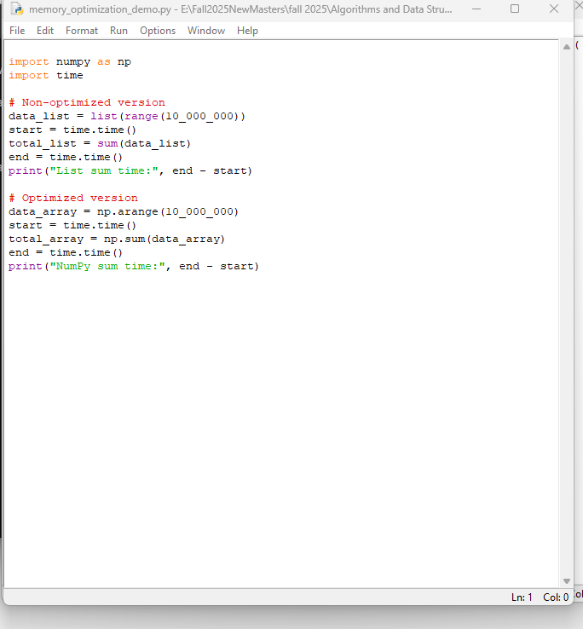
Figure 1. Python source code for the memory access optimization prototype.
Figure 2. Execution results showing faster NumPy summation time.
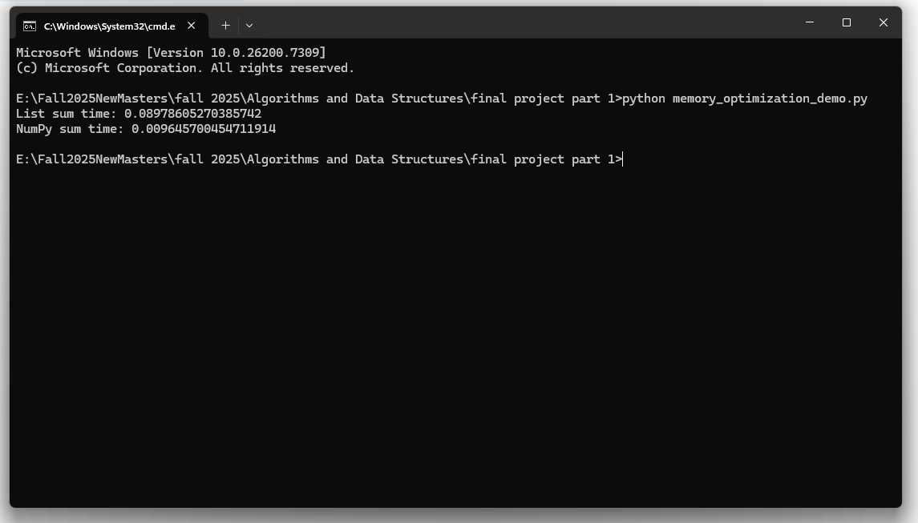
Lessons Learned and Comparison with the Empirical Study
The empirical study explains that poor memory locality and inefficient use of micro-architecture are common in HPC performance bugs. This prototype validates that theory in a simplified context.
Key lessons learned:
- Python lists have poor memory locality because their elements are stored in non-contiguous memory, which slows down access and processing.
- NumPy arrays store data in contiguous memory blocks, improving cache usage and reducing memory latency.
- Vectorized NumPy operations avoid slow Python loops and provide faster, hardware-efficient computation.
- The performance improvements observed in the experiment match the findings of the empirical HPC study on memory inefficiencies.
- Even small optimization changes such as switching to NumPy arrays can significantly improve performance for large datasets.
- The experiment confirms that memory-aware data structure design is an effective optimization strategy and aligns with patterns seen in real HPC performance bugs.
GitHub Repository Link
https://github.com/ksyed5837/Final-Project---Optimization-Technique-and-Implementation-Project-

Conclusion
Memory access optimization directly impacts HPC performance by improving cache efficiency and reducing memory latency. The empirical study highlights memory inefficiencies as a major cause of HPC performance bugs. The Python prototype illustrates that data structure optimization moving from Python lists to contiguous NumPy arrays provides clear performance gains. This demonstrates the practical importance of memory access optimization in real-world HPC and scientific computing environments.

References
Azad, M. A. K., Iqbal, N., Hassan, F., & Roy, P. (2023). An empirical study of high performance computing (HPC) performance bugshttps://ieeexplore.ieee.org/document/10174003
Han, X., & Yu, T. (2016). An empirical study on performance bugs for configurable software systems.
Jin, G., Song, L., Shi, X., Scherpelz, J., & Lu, S. (2012). Understanding and detecting real-world performance bugs. https://www.researchgate.net/publication/372328919_An_Empirical_Study_of_High_Performance_Computing_HPC_Performance_Bugs
Kehl, C., van Sebille, E., & Gibson, A. (2021). Accelerating Python fluid simulations with optimized data structures. https://arxiv.org/abs/2105.00057
Reed, D. A., Gannon, D., & Dongarra, J. (2022). Reinventing high performance computing. https://www.researchgate.net/publication/359080824_Reinventing_High_Performance_Computing_Challenges_and_Opportunities
Van der Walt, S., Colbert, S. C., & Varoquaux, G. (2011). The NumPy array: A structure for efficient numerical computation. https://www.researchgate.net/publication/372328919_An_Empirical_Study_of_High_Performance_Computing_HPC_Performance_Bugs

